

**SIMATS SCHOOL OF ENGINEERING**

**SAVEETHA INSTITUTE OF MEDICAL AND TECHNICAL SCIENCES**

**CHENNAI-602105**

**Currency Converter**

**A CAPSTONE PROJECT REPORT**

*Submitted in the partial fulfillment for the award of the degree of*

**BACHELOR OF ENGINEERING**

**IN**

**COMPUTER SCIENCE**

**Submitted by**

**T.R. Tharun Kumar (Reg no:192211541)**

**K. Madhan Kumar (Reg no:192211186)**

**Under the Supervision of**

**Ms. B. Jeevashri**

**June 2024**

**DECLARATION**

We, **T.R. Tharun Kumar, K. Madhan Kumar** students of **Bachelor of Engineering in computer science**, Department of Computer Science and Engineering, Saveetha Institute of Medical and Technical Sciences, Saveetha University, Chennai, hereby declare that the work presented in this Capstone Project Work entitled **currency convertor** is the outcome of our own bonafide work and is correct to the best of our knowledge and this work has been undertaken taking care of Engineering Ethics.

1. T.R Tharun Kumar 192211541
2. K. Madhan Kumar 192211186

Date:

Place:

**CERTIFICATE**

This is to certify that the project entitled **“Currency Convertor”** submitted by **T.R. Tharun Kumar, K. Madhan Kumar,** has been carried out under my supervision. The project has been submitted as per the requirements in the current semester of B.E. Computer Science.

Teacher-in-charge

**Ms. B. Jeevashri**

**Table of Contents**

|  |  |
| --- | --- |
| **S.NO** | **TOPICS** |
|  | **Abstract** |
| 1 | **Introduction** |
| 2 | **Project Description** |
| 3 | **Problem Description** |
| 4 | **Tool Description** |
| 5 | **Operations** |
| 6 | **Approach / Module Description / Functionalities**  6.1 Home  6.2 About Us  6.3 Help  6.4 Contact Us |
| 7 | **Implementation** |
| 8 | **Result** |
| 9 | **Conclusion** |
|  | **References** |

**Abstract**

A currency converter is a financial tool designed to calculate the value of one currency in terms of another currency based on current exchange rates. This tool is crucial for international trade, travel, and investment, providing users with real-time information on currency values. The converter utilizes live data from financial markets to ensure accurate and up-to-date conversions. The primary features include a user-friendly interface, support for multiple currencies, historical data analysis, and integration with financial APIs for real-time updates. The currency converter can be implemented as a standalone application or integrated into websites and mobile apps, offering accessibility and convenience for users worldwide. This paper discusses the design, functionality, and implementation of a currency converter, highlighting its significance in the global economy and potential enhancements for improved performance and user experience.

1. **Introduction**

In today's globalized economy, currency exchange plays a pivotal role in international trade, travel, and financial investment. As individuals and businesses engage in cross-border transactions, the need for accurate and timely currency conversion becomes essential. A currency converter is a tool that facilitates this process by converting the value of one currency into another based on current exchange rates. This tool not only aids in understanding the relative value of different currencies but also assists in making informed financial decisions.

Currency converters leverage real-time data from financial markets to provide up-to-date conversion rates, ensuring users receive precise and reliable information. They cater to a wide range of users, from tourists planning their travel expenses to multinational corporations managing their global finances. The utility of a currency converter extends beyond simple calculations; it can also offer historical data analysis, trend predictions, and integration with financial systems for automated conversions.

This paper delves into the mechanics of currency converters, exploring their design, operation, and application. It examines the underlying algorithms, data sources, and user interface considerations that contribute to their effectiveness. Furthermore, the paper discusses the broader economic implications of currency converters, highlighting their role in promoting global commerce and financial stability. Through this exploration, we aim to underscore the importance of currency converters in the modern financial landscape and propose potential enhancements to optimize their performance and user experience.

1. **Project Description**

At Currency Converter, we are dedicated to providing you with the most accurate and up-to-date exchange rates for all your currency conversion needs. Whether you're a traveller, a business professional, or just someone who needs to convert currencies, our goal is to make the process as seamless and efficient as possible.

Our mission is to deliver reliable and real-time currency conversion data to our users. We aim to simplify the complexities of currency exchange and help you make informed financial decisions, no matter where you are in the world.

**Accuracy:** We partner with reputable financial data providers to ensure our exchange rates are always accurate and up-to-date.  
  
**Convenience:** Access our services from any device, anywhere in the world. Our responsive design ensures a smooth experience on both desktop and mobile.  
  
**Security:** We prioritize your privacy and security, using advanced technologies to protect your data.

1. **Problem Description**

**Real-time Data Accuracy and Availability:**

* Currency converters rely on real-time exchange rate data from financial markets. Fluctuations in exchange rates can occur rapidly, and ensuring that the converter always uses the most current data is a significant challenge. Delays in data updates can lead to inaccurate conversions, potentially causing financial losses for users.

**Data Source Reliability:**

* The accuracy of a currency converter depends on the reliability of its data sources. Inconsistent or unreliable data sources can result in incorrect exchange rates. Ensuring the credibility and consistency of data providers is essential for maintaining the trustworthiness of the converter.

**Security Concerns:**

* Currency converters that handle financial transactions or personal data must ensure robust security measures to protect against data breaches and cyberattacks. Ensuring the privacy and security of user information is paramount.

**Offline Accessibility:**

* In regions with limited internet connectivity, users may need offline access to currency conversion tools. Developing solutions that provide accurate conversions without relying on constant internet access is an important consideration.

**Localization and Language Support:**

* Providing localized versions of the currency converter with support for multiple languages and regional formats is essential to cater to a global user base. Ensuring that the tool is accessible and understandable to users from different cultural backgrounds can enhance its usability.

**User Trust and Education:**

* Building user trust in the accuracy and reliability of the currency converter is crucial. Additionally, educating users about the factors affecting exchange rates and the limitations of the converter can help manage their expectations and enhance their understanding of the tool.

1. **Tool Description**

**User interface:**

**Programming Languages:**

* **JavaScript:** Used for building interactive and dynamic user interfaces. Often used in combination with frameworks like React or Angular for frontend development.
* **HTML/CSS:** For structuring the user interface and styling elements.
* **XAMPP** tool are also used for this website.

**Frontend Frameworks:**

* **React.js:** A popular JavaScript library for building user interfaces. It allows for the creation of reusable UI components and supports efficient rendering of data.
* **Angular:** A platform and framework for building single-page client applications using HTML and TypeScript.
* **Vue.js:** Another JavaScript framework for building reactive user interfaces.

**Features:**

**Mobile Optimization:** Optimize the currency converter for mobile devices with responsive design and native app development (e.g., using React Native). Ensure consistent performance across various screen sizes and operating systems.

**Feedback Mechanisms:** Implement feedback loops and user surveys to gather input and improve the currency converter based on user preferences and suggestions. Continuous iteration based on user feedback can enhance overall satisfaction and usability.

1. **Operations**

A currency converter typically involves the following operations:

1. **Input Amount**: The user inputs the amount of money they want to convert.
2. **Select Currencies**: The user selects the source currency (the currency they have) and the target currency (the currency they want).
3. **Fetch Exchange Rates**: The converter fetches the current exchange rate between the source currency and the target currency. This can be done using various APIs provided by financial services.
4. **Calculate Conversion**: The input amount is multiplied by the exchange rate to get the equivalent amount in the target currency.
5. **Display Result**: The converted amount is displayed to the user.
6. **Fee Calculation (Optional)**: If the currency conversion service charges a fee, this fee is calculated and added to the transaction, and the final amount after fees is displayed.
7. **Historical Data (Optional)**: Some converters provide historical exchange rate data, allowing users to see past rates or trends over time.
8. **Error Handling**: The converter should handle errors such as invalid inputs, network issues, or unavailability of exchange rate data.
9. **Round-off and Formatting**: The converted amount is often rounded off to a certain number of decimal places and formatted according to the target currency’s standard.
10. **Approach**

### Choose a Data Source for Exchange Rates

* Use a reliable API for real-time exchange rates (e.g., Open Exchange Rates, CurrencyLayer, Fixer.io).
* Ensure the chosen API supports the currencies you need.
* Design the Application.
* Set Up the Environment
* Integrate Backend and Frontend
* Test the Application
* Deploy the Application
* Maintenance and Updates

**Module Description:**

#### User Interface (UI) Module

**Description**: Handles user interaction and displays the converted currency.

1. Home
2. About us
3. Help
4. Contact Us

**Functionalities:**

This are the Functionalities for the currency converter.

**Core Functionalities:**

1. **Real-Time Conversion.**
2. **Exchange Rate Fetching**
3. **Currency Selection.**

### Additional Functionalities

1. **Historical Conversion**
2. **Multiple Conversions**
3. **Rate Refresh**
4. **Offline Mode**
5. **User Interface**
6. **User Preferences**
7. **Conversion History**
8. **Error Handling**

**Advanced Functionalities**

1. **Currency Trends**
2. **Localization**
3. **Implementation**

**Main page**

<!DOCTYPE html>

<html lang="en">

<head>

<meta charset="UTF-8">

<title>Currency Converter</title>

<link rel="stylesheet" href="style.css">

<style>

body {

margin: 0;

}

.container {

background: white;

margin-top: 2rem;

margin-left: 40%;

padding: 30px;

border-radius: 10px;

box-shadow: 0 0 10px rgba(0, 0, 0, 0.1);

width: 300px;

}

h1 {

margin-bottom: 20px;

}

.conversion-box {

display: inline-block;

text-align: left;

}

input, select, button {

display: block;

width: 100%;

margin: 10px 0;

padding: 10px;

font-size: 16px;

border-radius: 5px;

border: 1px solid #ccc;

}

button {

background-color: #007BFF;

color: white;

border: none;

cursor: pointer;

}

button:hover {

background-color: #0056b3;

}

#result, #exchangeRate {

margin-top: 20px;

font-size: 18px;

color: #333;

}

.error {

color: red;

margin-top: 10px;

}

</style>

</head>

<body>

<header>

<h1>Currency Converter</h1>

</header>

<div id="navigation">

<a id="homeBtn" href="INTERNET-PROGRAMING-PROJECT.html" class="link">Home</a>

<a href="#" class="link" onclick="loadDoc()">About Us</a>

<a href="#" class="link" onclick="l()">Help</a>

<a href="#" class="link" onclick="load()">Contact Us</a>

</div>

<div class="container">

<h2>Currency Converter</h2>

<div class="conversion-box">

<input type="number" id="amount" placeholder="Enter amount">

<select id="fromCurrency">

<!-- Populated dynamically using JavaScript -->

</select>

<select id="toCurrency">

<!-- Populated dynamically using JavaScript -->

</select>

<button onclick="convertCurrency()">Convert</button>

<div id="result"></div>

<div id="exchangeRate"></div>

<div class="error" id="error"></div>

</div>

</div>

<div id="homeContent">

<!-- Content loaded by JavaScript will appear here -->

</div>

<script>

const countryList = {

AED: "United Arab Emirates Dirham", AFN: "Afghan Afghani", XCD: "East Caribbean Dollar", ALL: "Albanian Lek", AMD: "Armenian Dram", ANG: "Netherlands Antillean Guilder", AOA: "Angolan Kwanza", AQD: "Antarctican Dollar", ARS: "Argentine Peso", AUD: "Australian Dollar",

AZN: "Azerbaijani Manat", BAM: "Bosnia and Herzegovina Convertible Mark", BBD: "Barbadian Dollar", BDT: "Bangladeshi Taka", XOF: "West African CFA Franc", BGN: "Bulgarian Lev", BHD: "Bahraini Dinar", BIF: "Burundian Franc", BMD: "Bermudian Dollar", BND: "Brunei Dollar",

BOB: "Bolivian Boliviano", BRL: "Brazilian Real", BSD: "Bahamian Dollar", NOK: "Norwegian Krone", BWP: "Botswana Pula", BYR: "Belarusian Ruble", BZD: "Belize Dollar", CAD: "Canadian Dollar", CDF: "Congolese Franc", XAF: "Central African CFA Franc", CHF: "Swiss Franc",

CLP: "Chilean Peso", CNY: "Chinese Yuan Renminbi", COP: "Colombian Peso", CRC: "Costa Rican Colon", CUP: "Cuban Peso", CVE: "Cape Verdean Escudo", CYP: "Cypriot Pound", CZK: "Czech Koruna", DJF: "Djiboutian Franc", DKK: "Danish Krone", DOP: "Dominican Peso",

DZD: "Algerian Dinar", ECS: "Ecuadorian Sucre", EEK: "Estonian Kroon", EGP: "Egyptian Pound", ETB: "Ethiopian Birr", EUR: "Euro", FJD: "Fijian Dollar", FKP: "Falkland Islands Pound", GBP: "British Pound Sterling", GEL: "Georgian Lari", GGP: "Guernsey Pound",

GHS: "Ghanaian Cedi", GIP: "Gibraltar Pound", GMD: "Gambian Dalasi", GNF: "Guinean Franc", GTQ: "Guatemalan Quetzal", GYD: "Guyanaese Dollar", HKD: "Hong Kong Dollar", HNL: "Honduran Lempira", HRK: "Croatian Kuna", HTG: "Haitian Gourde", HUF: "Hungarian Forint",

IDR: "Indonesian Rupiah", ILS: "Israeli New Sheqel", INR: "Indian Rupee", IQD: "Iraqi Dinar", IRR: "Iranian Rial", ISK: "Icelandic Krona", JMD: "Jamaican Dollar", JOD: "Jordanian Dinar", JPY: "Japanese Yen", KES: "Kenyan Shilling", KGS: "Kyrgyzstani Som",

KHR: "Cambodian Riel", KMF: "Comorian Franc", KPW: "North Korean Won", KRW: "South Korean Won", KWD: "Kuwaiti Dinar", KYD: "Cayman Islands Dollar", KZT: "Kazakhstani Tenge", LAK: "Laotian Kip", LBP: "Lebanese Pound", LKR: "Sri Lankan Rupee", LRD: "Liberian Dollar",

LSL: "Lesotho Loti", LTL: "Lithuanian Litas", LVL: "Latvian Lats", LYD: "Libyan Dinar", MAD: "Moroccan Dirham", MDL: "Moldovan Leu", MGA: "Malagasy Ariary", MKD: "Macedonian Denar", MMK: "Myanma Kyat", MNT: "Mongolian Tugrik", MOP: "Macanese Pataca",

MRO: "Mauritanian Ouguiya", MTL: "Maltese Lira", MUR: "Mauritian Rupee", MVR: "Maldivian Rufiyaa", MWK: "Malawian Kwacha", MXN: "Mexican Peso", MYR: "Malaysian Ringgit", MZN: "Mozambican Metical", NAD: "Namibian Dollar", XPF: "CFP Franc", NGN: "Nigerian Naira",

NIO: "Nicaraguan Cordoba", NPR: "Nepalese Rupee", NZD: "New Zealand Dollar", OMR: "Omani Rial", PAB: "Panamanian Balboa", PEN: "Peruvian Nuevo Sol", PGK: "Papua New Guinean Kina", PHP: "Philippine Peso", PKR: "Pakistani Rupee", PLN: "Polish Zloty",

PYG: "Paraguayan Guarani", QAR: "Qatari Rial", RON: "Romanian Leu", RSD: "Serbian Dinar", RUB: "Russian Ruble", RWF: "Rwandan Franc", SAR: "Saudi Riyal", SBD: "Solomon Islands Dollar", SCR: "Seychellois Rupee", SDG: "Sudanese Pound", SEK: "Swedish Krona",

SGD: "Singapore Dollar", SKK: "Slovak Koruna", SLL: "Sierra Leonean Leone", SOS: "Somali Shilling", SRD: "Surinamese Dollar", STD: "Sao Tome and Principe Dobra", SVC: "Salvadoran Colon", SYP: "Syrian Pound", SZL: "Swazi Lilangeni", THB: "Thai Baht",

TJS: "Tajikistani Somoni", TMT: "Turkmenistani Manat", TND: "Tunisian Dinar", TOP: "Tongan Pa'anga", TRY: "Turkish Lira", TTD: "Trinidad and Tobago Dollar", TWD: "New Taiwan Dollar", TZS: "Tanzanian Shilling", UAH: "Ukrainian Hryvnia", UGX: "Ugandan Shilling",

USD: "United States Dollar", UYU: "Uruguayan Peso", UZS: "Uzbekistan Som", VEF: "Venezuelan Bolivar Fuerte", VND: "Vietnamese Dong", VUV: "Vanuatu Vatu", YER: "Yemeni Rial", ZAR: "South African Rand", ZMK: "Zambian Kwacha", ZWD: "Zimbabwean Dollar"

};

const fromCurrencySelect = document.getElementById('fromCurrency');

const toCurrencySelect = document.getElementById('toCurrency');

// Populate options for fromCurrency and toCurrency selects

for (let currencyCode in countryList) {

const option1 = document.createElement('option');

option1.value = currencyCode;

option1.textContent = `${currencyCode} (${countryList[currencyCode]})`;

fromCurrencySelect.appendChild(option1);

const option2 = document.createElement('option');

option2.value = currencyCode;

option2.textContent = `${currencyCode} (${countryList[currencyCode]})`;

toCurrencySelect.appendChild(option2);

}

async function convertCurrency() {

const amount = parseFloat(document.getElementById('amount').value);

const fromCurrency = document.getElementById('fromCurrency').value;

const toCurrency = document.getElementById('toCurrency').value;

const apiKey = '35878e7ef99280151963781f'; // Replace with your actual API key

if (isNaN(amount) || amount <= 0) {

document.getElementById('error').innerText = 'Please enter a valid amount';

document.getElementById('result').innerText = '';

document.getElementById('exchangeRate').innerText = '';

return;

}

const url = `https://v6.exchangerate-api.com/v6/${apiKey}/pair/${fromCurrency}/${toCurrency}/${amount}`;

try {

const response = await fetch(url);

if (!response.ok) {

throw new Error(`HTTP error! Status: ${response.status}`);

}

const data = await response.json();

if (data.result === 'error') {

throw new Error(data['error-type']);

}

const convertedAmount = data.conversion_result;

document.getElementById('result').innerText =

`${amount.toFixed(2)} ${fromCurrency} = ${convertedAmount.toFixed(2)} ${toCurrency}`;

// Calculate and display the exchange rate for 1 unit of fromCurrency

const exchangeRate = convertedAmount / amount;

document.getElementById('exchangeRate').innerText =

`1 ${fromCurrency} = ${exchangeRate.toFixed(4)} ${toCurrency}`;

document.getElementById('error').innerText = '';

} catch (error) {

console.error('Error fetching exchange rates:', error);

document.getElementById('error').innerText =

'Error fetching exchange rates. Please try again later.';

document.getElementById('result').innerText = '';

document.getElementById('exchangeRate').innerText = '';

}

}

function loadDoc() {

const xhttp = new XMLHttpRequest();

xhttp.onload = function() {

document.getElementById("homeContent").innerHTML = this.responseText;

}

xhttp.open("GET", "123.txt");

xhttp.send();

}

function load() {

const xhttp = new XMLHttpRequest();

xhttp.onload = function() {

document.getElementById("homeContent").innerHTML = this.responseText;

}

xhttp.open("GET", "contact.html");

xhttp.send();

}

function l() {

const xhttp = new XMLHttpRequest();

xhttp.onload = function() {

document.getElementById("homeContent").innerHTML = this.responseText;

}

xhttp.open("GET", "help.txt");

xhttp.send();

}

</script>

</body>

</html>

**Database**

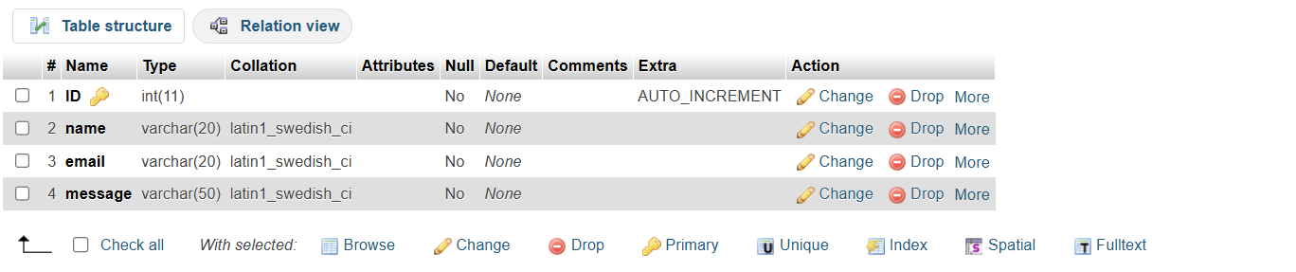

**Connection Php**

<?php

if ($_SERVER["REQUEST_METHOD"] == "POST") {

// Check if required fields are present in the POST data

$name = isset($_POST['name']) ? $_POST['name'] : '';

$email = isset($_POST['email']) ? $_POST['email'] : '';

$message = isset($_POST['message']) ? $_POST['message'] : '';

// Create connection (replace with your actual database credentials)

$conn = new mysqli('localhost', 'root', '', 'test');

// Check connection

if ($conn->connect_error) {

die("Connection error: " . $conn->connect_error);

}

// Prepare and bind statement

$stmt = $conn->prepare("INSERT INTO t2 (name, email, message) VALUES (?, ?, ?)");

$stmt->bind_param("sss", $name, $email, $message);

// Execute statement

if ($stmt->execute()) {

echo "<script>

alert('Thanks for submitting!');

window.location.href = 'http://localhost:8000/INTERNET-PROGRAMING-PROJECT.html#';

</script>";

} else {

echo "Error: " . $stmt->error;

}

$stmt->close();

$conn->close();

} else {

echo "Error: Invalid request method."; }

?>

**Contact us**

<!DOCTYPE html>

<html lang="en">

<head>

<meta charset="UTF-8">

<title>Contact Us</title>

</head>

<body>

<h2>Contact Us</h2>

<p>We are here to help you with all your currency conversion needs. If you have any questions, feedback, or need assistance, please don't hesitate to reach out to us.</p>

<h2>Customer Support</h2>

<p>Our customer support team is available to assist you from Monday to Friday, 9 AM to 6 PM (GMT).</p>

<ul>

<li>Email: <a href="mailto:support@currencyconverter.com">support@currencyconverter.com</a></li>

<li>Phone: +1 (800) 123-4567</li>

</ul>

<h2>Office Location</h2>

<p>Our main office is located at:</p>

<address>

Currency Converter Inc.<br>

123 Finance Street,<br>

Suite 456,<br>

New York, NY 10001<br>

USA

</address>

<h2>Feedback Form</h2>

<p>We value your feedback. Please fill out the form below to send us your comments and suggestions.</p>

<form method="post" action="http://localhost/connection.php">

<label for="name">Name:</label><br>

<input type="text" id="name" name="name"><br><br>

<label for="email">Email:</label><br>

<input type="email" id="email" name="email"><br><br>

<label for="message">Message:</label><br>

<textarea id="message" name="message" rows="4" cols="50"></textarea><br><br>

<button type="submit">Submit</button>

</form>

</body>

</html>

**About Us**

<h2>Welcome to Currency Converter!</h3>

<p>At Currency Converter, we are dedicated to providing you with the most accurate and up-to-date exchange rates for all your currency conversion needs. Whether you're a traveler, a business professional, or just someone who needs to convert currencies, our goal is to make the process as seamless and efficient as possible.</p>

<h3>Our Mission:</h3>

<p>Our mission is to deliver reliable and real-time currency conversion data to our users. We aim to simplify the complexities of currency exchange and help you make informed financial decisions, no matter where you are in the world.<p>

<h2>Why Choose Us?</h2>

<p><b>Accuracy:</b> We partner with reputable financial data providers to ensure our exchange rates are always accurate and up-to-date.<br><br>

<b>Convenience:</b>Access our services from any device, anywhere in the world. Our responsive design ensures a smooth experience on both desktop and mobile.<br><br>

<b>Security:</b> We prioritize your privacy and security, using advanced technologies to protect your data.<br><br>

**Help**

<p>Welcome to the Currency Converter Help page! Here you will find information on how to use our currency converter and answers to common questions.</p>

<h2>How to Use the Currency Converter</h2>

<ol>

<li><strong>Select the Currency:</strong> Choose the currency you want to convert from the dropdown menu labeled "From".</li>

<li><strong>Enter the Amount:</strong> Input the amount of money you wish to convert in the "Amount" field.</li>

<li><strong>Select the Target Currency:</strong> Choose the currency you want to convert to from the dropdown menu labeled "To".</li>

<li><strong>Click Convert:</strong> Press the "Convert" button to see the converted amount.</li>

</ol>

<h2>Frequently Asked Questions (FAQs)</h2>

<h3>What is a currency converter?</h3>

<p>A currency converter is a tool that allows you to convert one currency into another using the current exchange rates.</p>

<h3>How accurate are the exchange rates?</h3>

<p>We strive to provide the most accurate and up-to-date exchange rates by using data from reliable financial sources. However, exchange rates may fluctuate and may not be the same as the rates offered by financial institutions at the exact moment of conversion.</p>

<h3>Is there a fee for using the currency converter?</h3>

<p>No, our currency converter is free to use. However, please note that financial institutions may charge fees or offer different exchange rates when you perform actual transactions.</p>

<h3>Can I use the currency converter for any currency?</h3>

<p>Our currency converter supports a wide range of global currencies. If you cannot find a specific currency, please contact our support team for assistance.</p>

**8.Result**

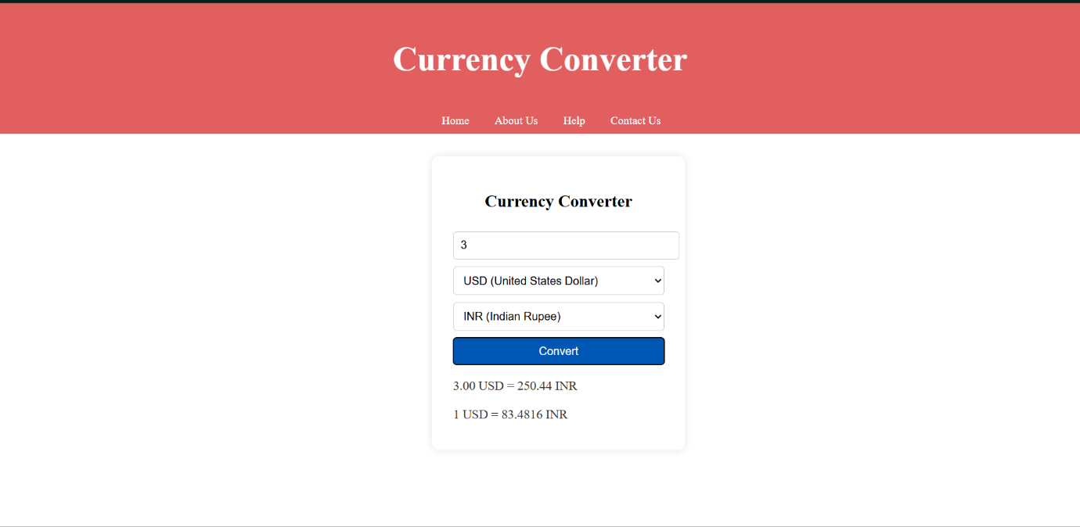

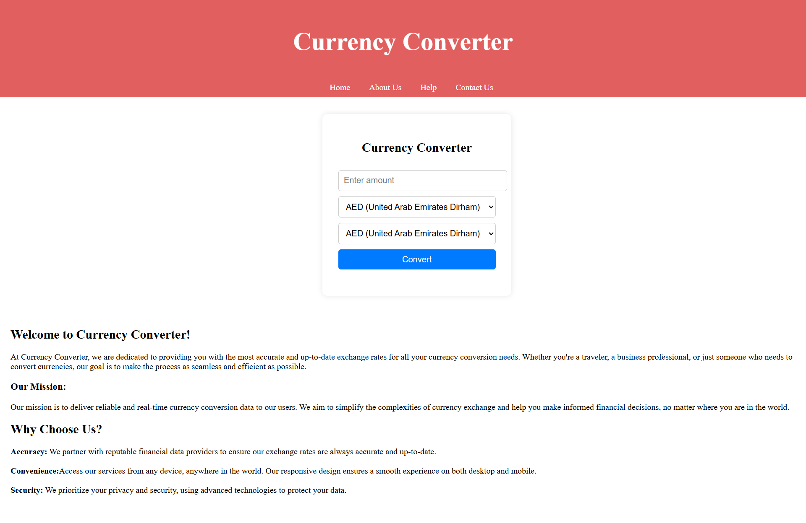

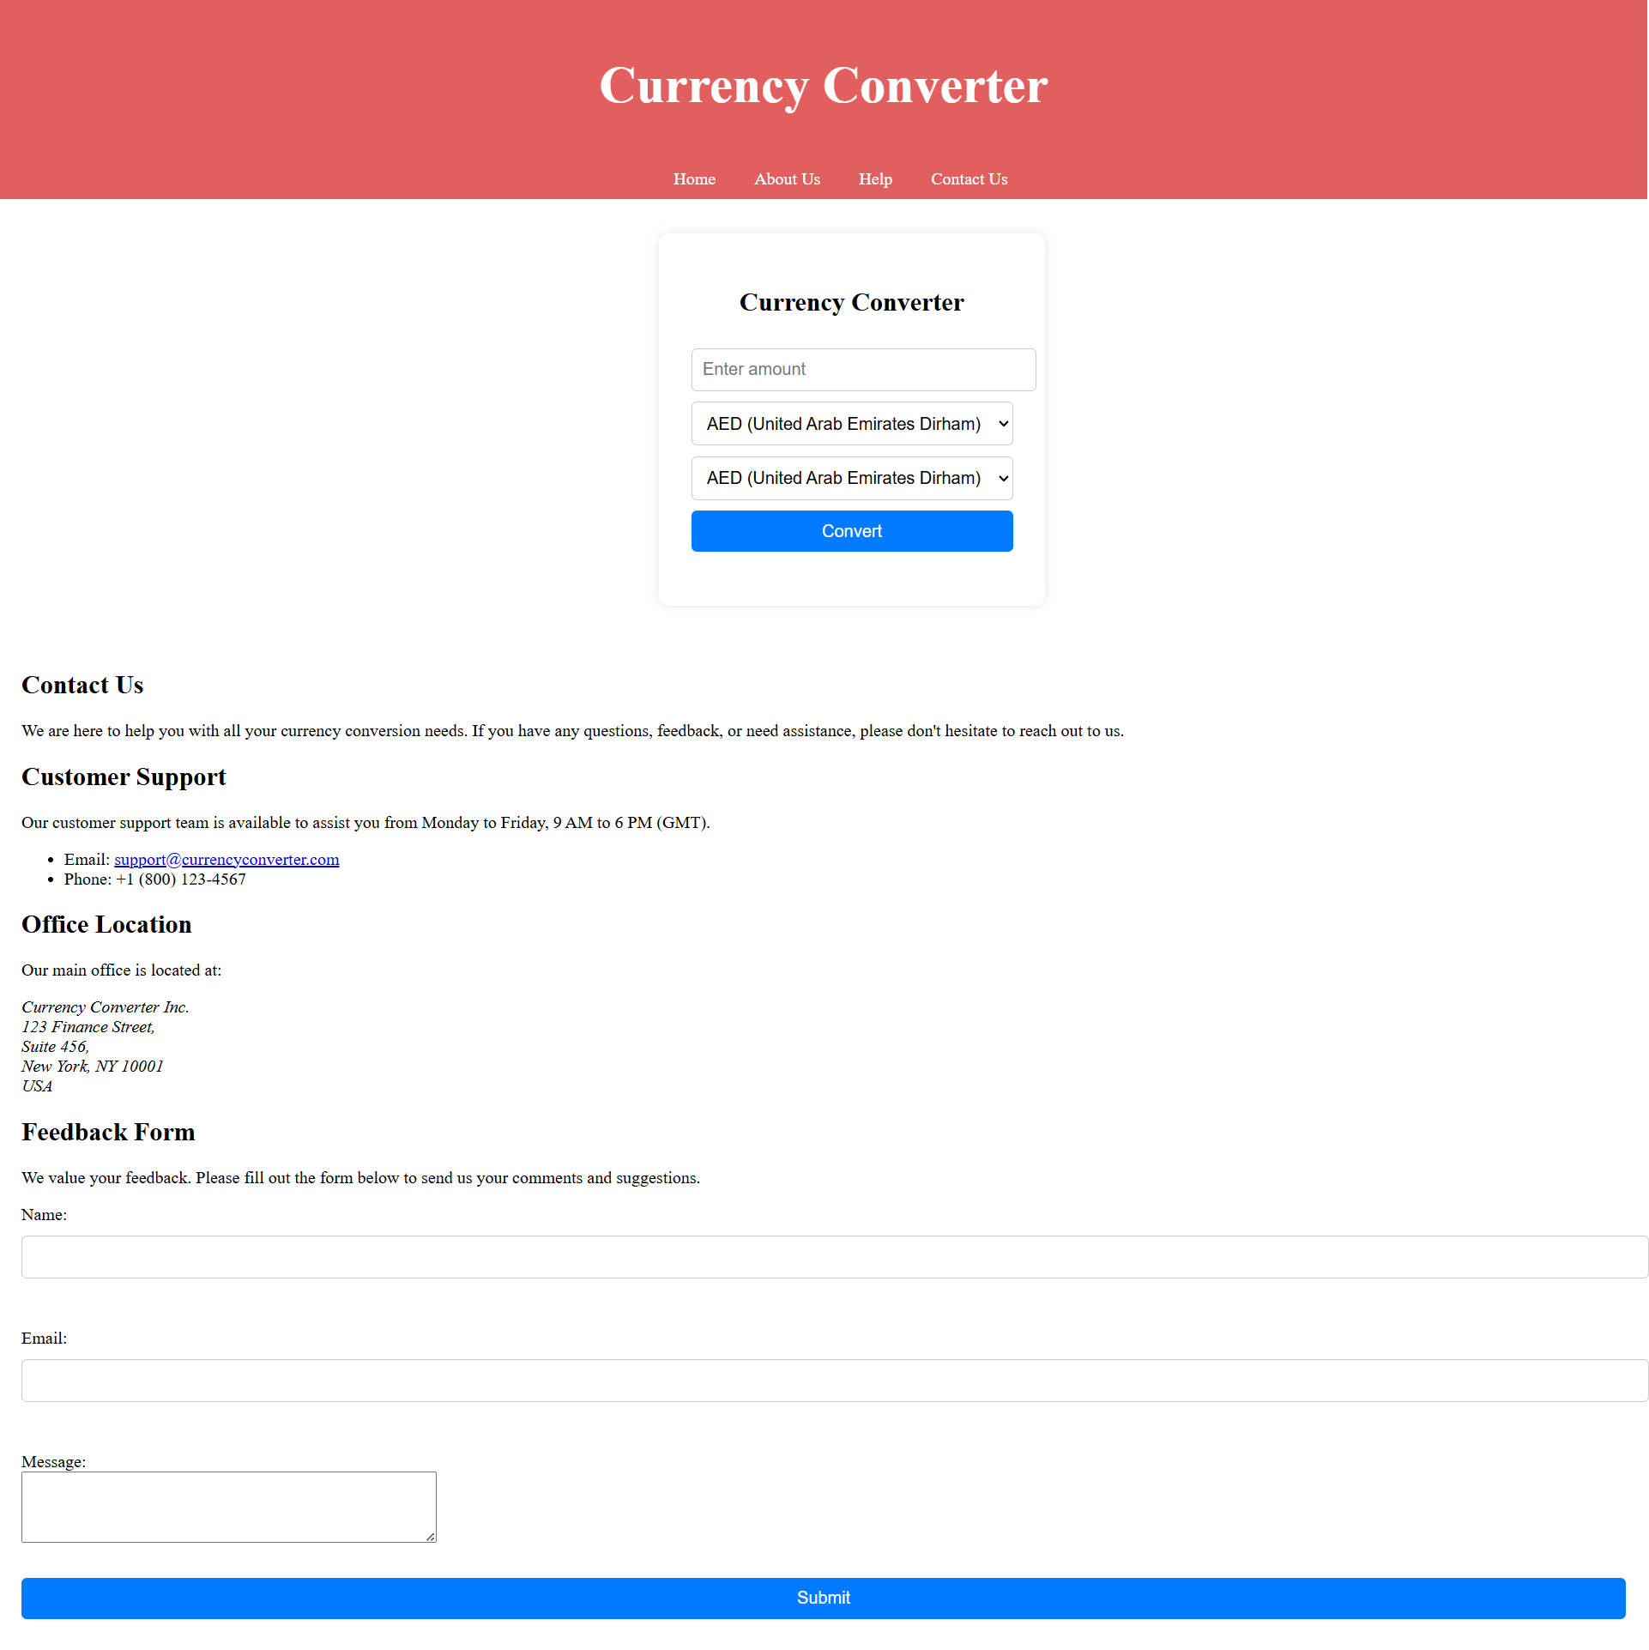

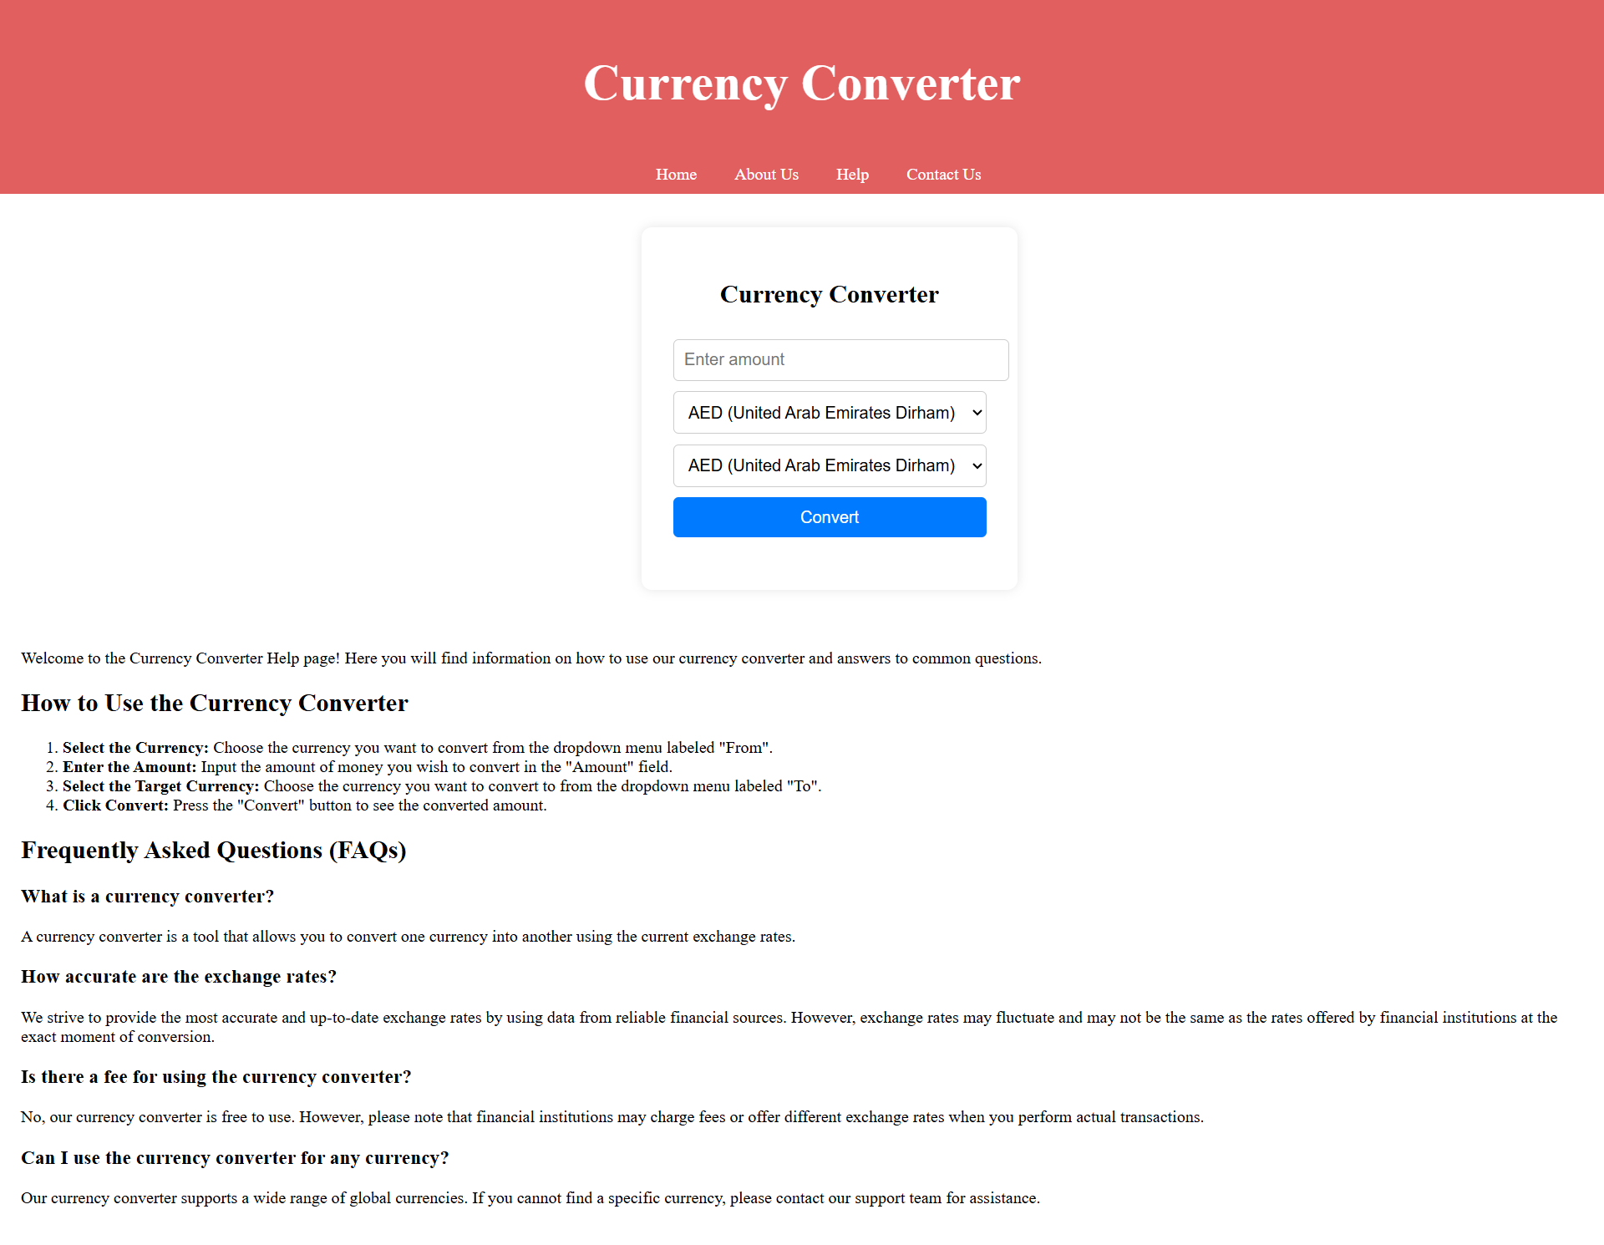

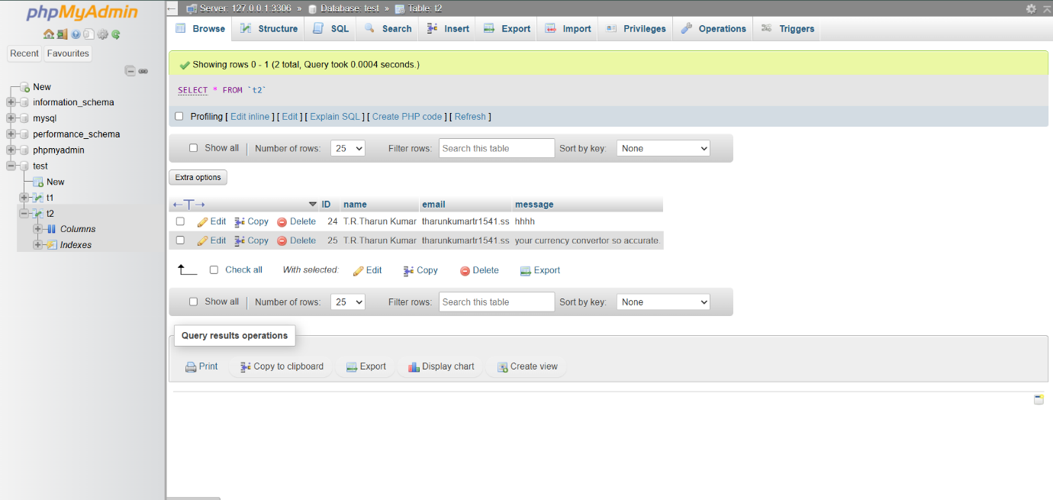

### 9. Conclusion and Future Enhancements

Looking ahead, there are numerous enhancements that can be made to a currency converter application to keep it relevant and increase its functionality. Enhanced data visualization through graphs and interactive dashboards can provide users with a better understanding of currency trends. Machine learning can be employed for predictive analytics, offering insights into future exchange rates and investment recommendations. Integration with financial tools, such as budgeting applications and payment platforms, can add significant value, while expanded currency support, including cryptocurrencies and local currencies, will ensure comprehensive coverage.

A multi-currency wallet feature could enable users to manage balances in various currencies seamlessly. Adding real-time market news and custom alerts can keep users informed about significant currency movements and economic events. Enhanced security features, such as advanced encryption and two-factor authentication, will protect user data, and incorporating localization and accessibility features will cater to a global and diverse audience. Finally, exploring blockchain technology for decentralized exchange rates and utilizing smart contracts for secure and automated processes can position the application at the forefront of financial innovation. Regular updates and user feedback will be crucial in refining and expanding the application's capabilities, ensuring it remains a valuable tool for users worldwide.

**References**

1. **XE Currency Converter**
2. **OANDA Currency Converter**,
3. **Google Currency Converter**
4. **X-Rates Currency Calculator**
5. **Wise Currency Convertor**